APPLICATION OF VVVF DRIVES IN BLAST FURNACE

A DISSERTATION

Submitted in partial fulfilment of the
requirements for the award of the degree

of

BACHELOR OF TECHNOLOGY
In
ELECTRICAL ENGINEERING

By
PRAGYA CHURENDRA


MAY-JUNE 2023

NATIONAL INSTITUTE OF TECHNOLOGY (NIT)
CANDIDATE’S DECLARATION

I hereby certify that the work which is being presented in the dissertation entitled “APPLICATION OF VVVF DRIVES IN BLAST FURNACE” in partial fulfilment of the requirements for the award of the Degree of Bachelor of Technology submitted to the Department of Electrical Engineering, National Institute of Technology (NIT), Raipur is an authentic record of my own work carried out during the period from 15-05-2023 to 10-06-23 under the supervision of Mr. VINEET JOHRI, DGM, Blast Furnaces.
The matter presented in this dissertation has not been submitted by me for the award of any other degree of this or any other Institute.

Date: 08-05-23 Signature
Place: BHILAI PRAGYA CHURENDRA

CERTIFICATE

This is to certify that the above statement made by the candidate is correct to the best of my knowledge and belief.

Date: 08-05-23 Signature
Place: Bhilai VINEET JOHRI

ABSTRACT
In blast-furnace, the raw materials like coke, sinter, iron ore needs to be charged inside the furnace in proper proportion to ensure a better chemistry inside the furnace. The chemical reactions inside a furnace are important for the quality and productivity of the furnace. The raw materials are filled through a sequence and are charged inside the furnace depending on the parameters defining the profile and chemistry. The raw materials are stored in different bunkers, fed through feeders to the conveyors and then screened to separate fines, finally weighed in a weighing hopper to the quantity required as per coke-non coke ratio. The filling of material is required to be in a controlled manner to have a quality check. This control in the filling is achieved through speed control of feeders. Apart from the quality aspect, life span of equipment also needs to be improved to match the availability of equipment for production. The application of VVVF in this aspect has shown significant results. Energy consumption is another concern in present industrial environment. The use of VVVF has provided a tool to conserve energy efficiently.
As a whole, the VVVF has become a necessary part in process control, quality control and energy control of any industry.

Table of Contents
 | DESCRIPTION | P.G. NO.
 | ABSTRACT | 1
1 | INTRODUCTION | 6
2 | MOTIVATION | 7
3  4  5  6  7  8  9  10  11  12  13  14 | BACKGROUND THEORY  INDUCTION MOTOR  VARIABLE FREQUENCY DRIVES  METHODOLOGY  CASE STUDY1  CASE STUDY2  CASE STUDY3  CASE STUDY4  CT AND VT  RESULT  CONCLUSION  REFERENCE | 8  16  23  24  29  31  33  42  43  47  48  49

CHAPTER 1
INTRODUCTION
  - INTRODUCTION
In a steel plant, the different motors are controlled by electric drives. Electric drive is very important equipment as it controls over critical parameters of the system. In this project the concentration is on the speed control of different critical motors for process control. Mainly, the AC drives used are of make Vacon, Yaskawa, ABB, Toshiba etc. These drives are used to control material feeding to a blast furnace, energy saving in a blast furnace as well as to enhance the lifetime of mechanical components of the system being used in the process
The development of high performance motor drives is very important in industrial as well as other purpose applications. Generally, a high performance motor drive system must have good dynamic speed command tracking and load regulating response. The AC motors are used in various applications such as industries, robotics etc. because of their simplicity, ease of application, reliability and favourable cost have long been a backbone of industrial applications. AC drives are normally less expensive for most power ratings. AC drives are now emerging as largely used adjustable speed machines and a wide range of options have involved for this purpose. In the applications to be detailed later in this report, the motor should be precisely controlled to give the desired performance.
  - MOTIVATION
- To understand the functionality of material feeding system in the Blast Furnace.
- To understand the energy saving phenomenon while using variable speed drives.
- To understand the reduction in the wear and tear of the mechanical system being driven by the AC drives.
- The drives which are used, has different application controls viz. basic application, standard application, local/remote application, multi-step speed control application, fan/pump application etc.
- Performing simulation of speed control of AC motor.
  - OBJECTIVE OF THE WORK
- To study the functionality of different equipment with variable speed control requirement in the blast furnace. The main concern behind choosing this is to understand the concept of precise speed control in AC motors by the application of VVVF (Variable Voltage Variable Frequency) drive.

  - TARGET SPECIFICATION
- Importance of variable frequency drives in material handling system in stock houses of Blast furnaces.
- Energy saving calculation in case of Combustion Air Fans of Blast Furnace Stoves using VVVF.
- VVVF application for accurate burden distribution in bell less top furnaces.
- Wear and Tear reduction in Coke Breeze Skip Winch Control.

CHAPTER 2
BACKGROUND THEORY AND LITERATURE REVIEW
A drive is made with the consideration of-
- Protection: A drive should have a good protection system over power section and control section.
- Interfacing: A drive should be made in such a way to interface it with other devices. Example- micro-controller, PLCs etc.
- Alarms: A drive should have alarms for indication of the faults or abnormal condition.
- Communication: A drive should be well communicable to the devices which are connected with it.
Induction Motor:
An AC induction motor essentially consists of two parts namely a stationary part called the "stator" and a rotating part called "rotor". The rotor is placed inside the stator and is supported on both sides. Energy is supplied to the windings placed in the stator slots. Energy is transferred to the rotor windings through electromagnetic induction and hence such motors are called "induction motors". Three Phase Induction Motor Construction: The stator consists of three-phase winding which are placed in the slots of a laminated stator core. The rotor core is a laminated steel cylinder, having slots in which conductors are cast or wound. The rotor bars are shortened at the both ends by rotor end-rings.
Principle:
When a three-phase supply is connected across the stator windings, a rotating magnetic field, constant in magnitude but rotating at synchronous speed, Ns, is produced. The speed of the rotating field so produced depends upon the supply frequency and the number of poles for which the winding is made. The direction of the rotating magnetic field produced by the stator depends upon the supply phase sequence. This field induces an electromotive force (emf) in the rotor conductors which in turn produces the current flow thus magnetizing the rotor. Due to the tendency of the rotor magnetic field to be aligned with the stator field, the rotor develops the torque in the same direction and it starts rotating. The speed of the rotor however is less than synchronous speed Ns (the speed of rotating magnetic field developed by the stator). If the rotor runs exactly at the synchronous speed induced emf in the rotor will be zero. Hence there will be no rotor current and rotor torque.
The synchronous speed is a function of the no of poles of the motor and supply frequency. This is given by:
Ns = 120 * frequency (f) / number of poles (P)
Hence the speed of an AC motor is a function of frequency and the number of motor poles. The speed of the rotor relative to that of the stator-rotating field is called as "SLIP". This slip is the difference between the synchronous speed, Ns and actual speed N and is denoted by S. This is generally expressed as a fraction of the synchronous speed. Thus slip is S = (Ns-N) / Ns where N- is actual rotor speed, Ns - Synchronous speed The primary function of the motor is to provide torque, which makes the shaft / loads to rotate at the required speed.
- The "torque" of an induction motor depends upon the flux in the air gap.
- Further, flux is directly proportional to V / f.... where V is supply voltage and f is the supply frequency. It can therefore be said that, the torque T is directly proportional to flux & flux is directly proportional to V / f.
- Thus the torque producing capability of the motor at the rated / required speeds can be retained constant, by maintaining the voltage v/s frequency ratio constant.
Conclusively one can say that to vary the speed of an induction motor the frequency of the supply going to the motor should be varied. In order to maintain the torque producing capability the voltage applied to the motor needs to change in the same proportion as that of frequency.
Speed control of Induction Motor:
The power supply to the induction motor is through the stator winding terminal. The speed control of the induction motor is possible at the stator winding terminal, by appropriately changing the electrical supply voltage, frequency or the internal winding. The rotor circuit windings available in a slipring induction motor, allows an additional means to control the speed. This method of varying the motor speed by adding resistance in the rotor circuit is known as rotor resistance control (RRC). The operating principle of RRC is explained as follows:
- In the rotor resistance control method, the speed variation in a motor can be achieved by altering the slip the motor can operate. This method is applicable for slipring induction motors, as it involves addition of the external resistance in the rotor circuit of the motor (as shown in fig ).The principle employed in the rotor resistance control is changing the internal motor circuit parameters, by adding external rotor resistance. This in turn changes the torque-speed characteristics of the motor.
- 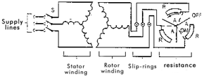
Figure1- Slip ring induction motor - with external rotor resistors
With increasing resistance, the slope of the motor curve decreases, shifting the stable operating point for the given load curve to a point with higher slip. Thus the speed control is achieved in the rotor resistance control.( This is represented in the fig. below)
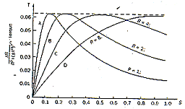
Figure2- Slip ring induction motor - with external rotor resistors
The above graph shows the variations of the torque with slip, the other factors remaining constant. The change in slip is attained by changing the value of rotor resistances. In the graph, the curves A, B, C & D have rotor resistances Ra, Rb, Rc & Rd respectively. The relative values of resistances are as follows: Rd>Rc>Rb>Ra. It is observed that a significant amount of input power has to be dissipated in the external resistors. This power lost due to the increase in slip is called as slip power. The ratio of slip power to total power input changes with speed.
Rotor Resistance Controller (RRC): Rotor Resistance Controller (RRC) is a method of speed control applicable to the slip-ring induction motor only.
Advantages of RRC:
- No harmonic generation: Unlike AC drives & SPRS, RRC has no adverse effect, such as harmonics generation which affects the distribution network.
- Ambient conditions: RRC has no electronic components like that of other electronic variable speed drives. Hence, they can be installed in even adverse environments.

Disadvantages of RRC:
- External cooling: A portion of the input power has to be dissipated in the external rotor resistors. These resistors require cooling fans to dissipate the heat generated by them. The cooling fans form an additional load.
- Speed adjustment: In this method the speed adjustment is in steps or with very poor regulations.
- Maintenance: This method of control has lot of contractors & other moving parts, which requires regular maintenance.
Variable Frequency Drives:
The primary functions of a variable speed AC drive, is to convert electrical power to the usable form for controlling speed, torque and direction of rotation of AC motor.
The AC drive system basically splits into two sections:
- Power electronics: In the power circuit the three phase incoming AC power is rectified to DC and then inverted to AC of desired frequency & voltage. This consists of surge suppresser circuit, line communicated converter (controlled or uncontrolled rectifier), pre-charging unit, DC link capacitor unit with bleeder resistor inverter, etc.
- Control circuitry: The control circuitry monitors &controls the whole working of the drive. It regulates the output voltage, processes the feedback, the fault and interlocks the inverter by tripping it in case of any fault. The modes of operation of AC drives are mainly classified into two types: Constant V / f and Vector control.

Concept of variable speed drives
Any variable speed electrical drive system comprises of the following components:
- An electronic actuator - the controller.
- A driving electrical machine - motor.
- A driven machine (load) - pump, fan, blower, compressor…
The task of a variable speed electrical drive is to convert the electrical power supplied by the mains into mechanical power with a minimum loss. To achieve an optimum technological process, the drive must be variable in speed. This will adjust the speed of the driven machine without step. This is ensured by the low loss control using solid state Technology in electronic controllers. The controllers are connected to mains supply and the electrical machine as shown in figure
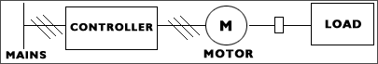
Figure3- Block diagram for VVVF application
- The solid - state devices, which convert the AC supply to DC supply were first used as variable speed devices, in DC technology. Using these devices the armature voltage of a DC motor and therefore the speed can be adjusted, almost without losses and over a wide range of speed. Using these features the drive can be designed which start smoothly and jerk-free. This helps to maintain the desired selected speed, independently of the load and operate with good dynamic response.
- The DC drive needs special consideration in some applications. For example in hazardous atmosphere, vibrations and higher speeds the usage of AC motor with squirrel cage rotor is advantageous. The use of frequency inverters (VFD's) to supply to AC Motors resulted in a new orientation of electrical power for handling variable speeds operation is shown in figure
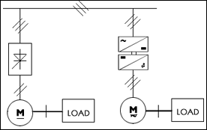
Figure4- DC drive and AC drive
- Every standard AC motor can be fitted with a variable speed drive using a frequency inverter. Frequency and voltage of the single - phase or three - phase mains are varied by the frequency inverter, such that the motor can be operated with varying speeds over large range settings. The operating mode of any motor connected to these variable speed drives can be classified in Four Quadrants, depending upon the Torque and Speed of the drive in figure above.

Four –Quadrant Operation:
A Four-quadrant diagram can represent mode of operation of variable speed drive. In Quadrant 1 the speed and torque can be represented positive or forward direction. This is consistent with a motor driving a load taking power from the mains. Similarly in Quadrant 3, both speed and torque are in negative or reverse direction.
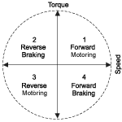
Figure5- Four quadrant diagram
This Corresponds to a motor turning in the reverse direction, driving a load and again taking power from the mains. In Quadrants 2 and 4, the speed and torque are in mutually - opposed directions, that is to say, the torque of the motor is opposing its rotation, giving a braking effect. It follows, then, that mechanical and kinetic energy of the load is being converted into electrical energy. The motor is behaving as a generator and the system as a whole is delivering power into the mains.
This behaviour is known as Regeneration. After going, through the mode of operation of VSDs, let us briefly discuss about the various loading patterns. The characteristics of the load are particularly important in the trouble -Free operation of VSDs. Load refers essentially to the torque output and the corresponding speed required. Loads can be broadly classified as follows
- Constant torque
- Variable torque
- Constant power
CONSTANT TORQUE LOAD
Constant torque load are those for which the output power requirement may vary with speed of operation, but the torque does not vary. Conveyors, rotary kilns and constant - displacement pumps are typical examples of constant torque loads.
VARIABLE TORQUE LOAD
Variable torque loads are those for which the torque required varies with speed of operation. Centrifugal pumps and fans are typical examples of variable torque loads (torque varies as the square of the speeds).

CONSTANT POWER LOAD
Constant power loads are those for which the torque requirements are typically changed inversely with speed. Winders, coilers are typically the examples of constant power loads.The largest potential for energy savings with variable speeds drive are generally in variable torque applications. For example, centrifugal pumps and fans, where the power requirements changes as the cubes of speed constant torque loads are suitable for VSD application.
The latest industrial trend is to use AC drives for variable speed application. As already discussed, to vary the speed of an AC motor and at the same time retain its torque producing capability a power source is required. This power source has to provide variable voltage and frequency output in such a way that, in most of the operating area the V / f ratio is maintained constant. This can be achieved through an AC drive which gives variable frequency and variable voltage as output by taking fixed voltage as input.
The principle involved in this technique is first to convert the fixed frequency, fixed voltage AC supply into a variable or constant DC voltage. This is then into the AC supply of desired frequency & amplitude. The criteria for the selection of AC inverter drive are essentially the same as for a DC variable speed drive. The latest developments in technology and successful development of electronic drives (AC drives) for cage motors have resulted in the following benefits:
- Availability of full load torque from standstill
- Absence of torque fluctuations at low speed.
- Ability to hold a set speed, regardless of load torque variation
- Ability to control the rate of increase & decrease of speed
- Dynamic response
Advantages of variable frequency drives:
Feature | Benefits
Soft starting | - Reduced impact on electrical network means no penalties from utility  - Reduced stress on motor, coupling and load, giving extended life time  - Unlimited number of starts per hour
Precise speed and torque control | - Better product quality  - Improved cost of ownership  - Better protection of motor (e.g. stall protection and load)  - Consistent product quality, despite input power variations and sudden load changes.
Wide speed control range | - Improved efficiency compared to traditional flow control methods e.g. damper control, throttling  - Lower maintenance
High reliability and availability | - Reduced downtime  - Improved process availability
Low audible noise | Improved working environment for operators
Capability for speed reversal / regenerative braking | - Desired torque during braking, therefore better product quality.  - Improved braking characteristics  - Higher efficiency
Flux optimisation (motor flux automatically adapted to load) | - Improved motor efficiency  - Reduced motor noise
Power loss ride through | - Reduced number of drive trips  - Better process availability
Automatic start (drive can catch a spinning load) | - Reduced waiting time  - Reduced downtime
Energy saving | AC drives can be retrofitted to standard induction motors, to provide substantial energy savings.

CHAPTER 3
METHODOLOGY
PERIPHERAL DIAGRAM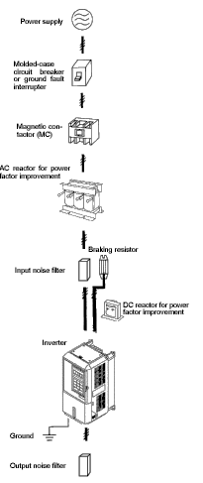
Figure6- Peripheral diagram for installation of VVVF
Case study 1: Installation of variable frequency drives in material handling system in stock houses of Blast furnaces
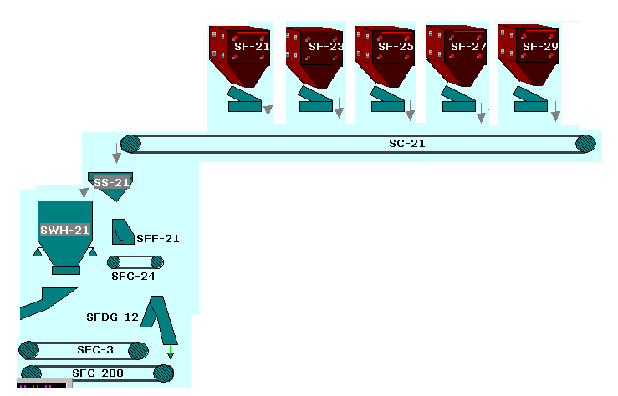
Figure7- Material feeding system in a Blast furnace
The above shown material feeding system is of Sinter feeding. The bunkers labelled SF-21, SF-23… are holding Sinter (raw material to blast furnace). These are transported through conveyor SC-21 to a screen SS-21 which separates out fines from the raw material and further feeds to a weigh hopper SWH-21. In the weigh hopper the desired amount is filled and further moved to be filled inside the furnace. The equipment labelled SFF-21, SFC-24, SFDG-12, SFC-3 and SFC-200 are for moving the fines that has been separated out during screening to different department for further use.
The important aspect in this system is the screening part as it ensures the quality of material fed inside the furnace. The fines if charged inside the furnace can choke the furnace and can disturb the chemistry inside the furnace that severely affects the production and quality of the hot metal which is the final output of a blast furnace. The screening being a critical parameter needs to be ensured proper and for this the rate at which material shall be fed to the screen is to be controlled. This feeding of material from a bunker to the screen can be controlled by the speed control of feeder motors attached to a bunker. This can be understood with the following figure.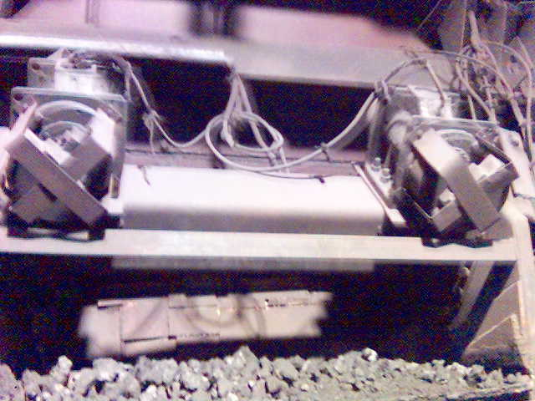
Figure8-Typical VIBRO-FEEDER equipped with two unbalanced squirrel cage motors for feeding raw material.
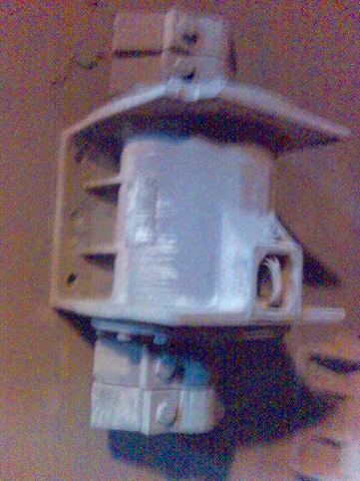
MOTOR
COUNTER
WEIGHTS
UNBALANCED VIBROFEEDER MOTOR

Figure9- Feeder motors with counter weights

COUNTER WEIGHT POSITION vs VIBRATION:
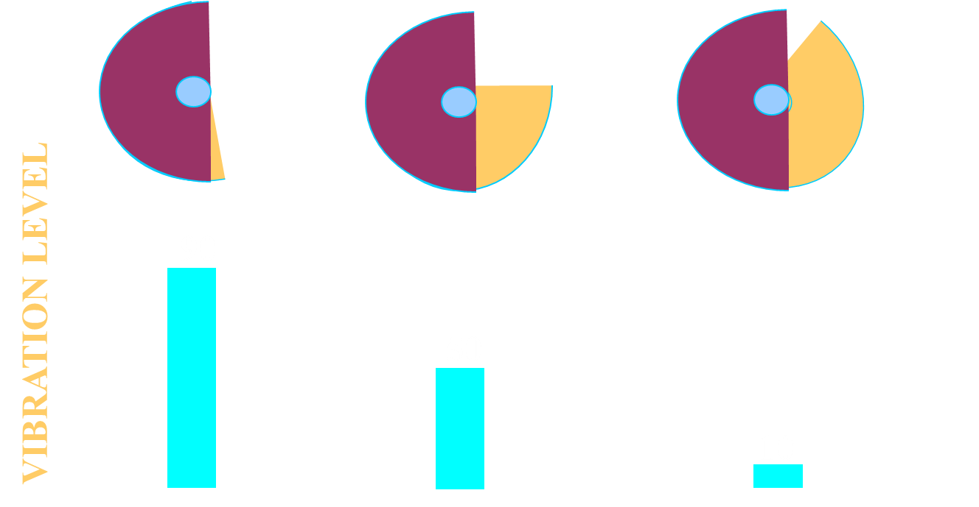
90
50
10
Figure10-Typical diagram showing vibration level wrt counter weight overlapping
The counter weights attached to the feeder motors when rotate with motor shaft provides a vibrating action in the feeders on which the motor is mounted as shown in figure8. Conventionally, counter weight covers of both the motors are removed and their counter weights adjusted for the desired feed-rate as shown in Figure10..

Distinct disadvantages of Conventional system
- Charging interrupted for 30 minutes.
- Manual intervention at site required.
- Unsafe working.
- Correction in feedrates is offline.
- Not very accurate adjustment.
- Human error in counter weight setting can lead to equipment damage or accidents
Advantages of using VVVF System
- Charging interrupted for 30 minutes. – Eliminated
- Manual intervention at site is required. – Eliminated
- Unsafe working. - N/A
- Correction in feed rates is offline. - Scope for improvement
- Not very accurate adjustment. - Scope for improvement
FEED-RATE CONTROL IN STEPS THROUGH VVVF YEAR 2000
MCCB

M
Step rpm

M
MCCB
VVVF
CONTACTOR
1

3

CHANGE OVER SWITCH
4

1

M
M
CONVENTIONAL SCHEME
OVERLOAD RELAY

PLC

Coarse control
1
2
3
4
Step rpm

Figure13-VVVF application with step frequency adjustment through PLC

Step Input

CLOSED LOOP ONLINE FEEDRATE CONTROL THROUGH PLC YEAR 2002
Communication/ Analog o/p
FEEDER
CONSTANTS
COMP.
D/A
F/R
CALC’N
PLC
HMI
VVVF
LOAD
CELL
M

4 – 20 mA

Figure14-VVVF application with closed loop control through PLC

MULTIPLE FEEDER CONTROL THROUGH COMMON VVVF
VVVF
3 PHASE SUPPLY
PLC

COMMON POWER BUS
M
M
M
Correction in feed rates is offline. - Online
Not very accurate adjustment. - Accurate
Figure15-VVVF application with multiple feeder control

M
CLOSED LOOP CONTROL THROUGH PLC COMMUNICATION NETWORK

PLC
HMI
M

Comm’n card

VVVF
M
VVVF
M
VVVF
M
VVVF
M

VVVF
VVVF

M
M

FEEDERS
SCREENS
CONVEYORS

Figure16-VVVF application with closed loop control through PLC

Case Study2: Combustion Air Fans of Blast Furnace Stoves using VVVF
INLET DAMPER
OUTLET DAMPER
AIR
STOVES

VVVF Control

AIR
Figure17-VVVF application in Fan control

Thus spoke Thomas Edison,” I shall make Electricity so cheap, that only the rich will afford candles”-such an utopia has not been realized but today energy conservation is a crucial issue all over the world. It is a harsh reality that conservation of energy is no more an option, but a “must” to remain competitive in the fierce world of global competition
Energy Saving Calculation Practically:
Power drawn by the motor (with damper) = 25.0 kW
Power drawn by the motor (without damper) = 11.0 kW
SAVING = 25.0 - 11.0 = 14.0 Kw
Average running hrs. of the Fan per day = 14 hrs.
Hence saving / day = 14 X 14 = 196 kWh = 196 X 4.2 = ` 823/-
Saving / month /fan = 823 X 30 = ` 24,696/-
Cost of the controller = ` 2, 90,000/-
Payback period = 290000 / 24696 = 11 months 21 days
Benefits:
- Vibration of the fan and the motor drastically got reduced because motor is now running at a lower speed.
- Less wear and tear to the Fan bearing and Impeller and thereby increasing its life.
- Due to the Soft Starting, damage to the motor rotor bars avoided.
- Save Environment.
- Saving of Electricity by around Rs 25,000/- per month / CA Fan
Case Study 3: VVVF application for accurate burden distribution in Bell Less Top furnaces

FURNACE

CHUTE

RINGS

Figure18-Material distribution through tilting mechanism

BELL LESS TOP TILTING MOTOR CONTROL

>2o
MAX
D/A
PRESET

VVVF
(4-20mA)

ACTUAL
<2o
PROPORTIONATE

>2o

ERROR

<2o

T I M E

Figure19-Motor control through encoder feedback

ADVANTAGES:

- VVVF drive is used to control the speed of chute tilting motor for accurate positioning of chute in particular ring.
- Smooth start and stop increases the life of motor, coupling brush, brake, transmission gearbox

Case Study 4: Coke Breeze Skip Winch Control through VVVF

4

3

TOP BUNKER
BOTTOM
BUNKER

Soft start
Normal speed
Slow down
Dynamic Braking

2

1

Figure20-Coke Breeze Skip winch control

LEFT UP

- Soft start
- Normal speed
- Slow down
- Dynamic Braking
RIGHT UP

Figure21-Coke Breeze Skip Movement
Advantages in Coke Breeze Winch Control

- Smooth operation of winch
- Reduced wear and tear – improving the availability of equipment
- Lower mechanical and electrical stress – reduced breakdowns and maintenance requirement
- Longer life of equipment and motors

CONNECTION DIAGRAM: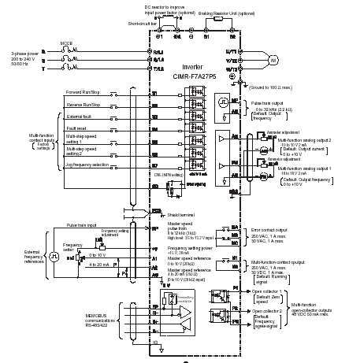

Basic set of parameter:
- Input Mode: This parameters defines the function of various inputs available. Figure given below shows input configuration for Two Wire Control, Single-Source Control Mode
- FREQUENCY SELECTION: this parameters control which of the frequency source is currently supplying the frequency command. Different sources can be
- Adapter
- Preset 1-7
- Use last
- Remote port
- 0-10 Volt Analog
- 4-20 mA Analog
- Pulse Reference
- Fieldbus

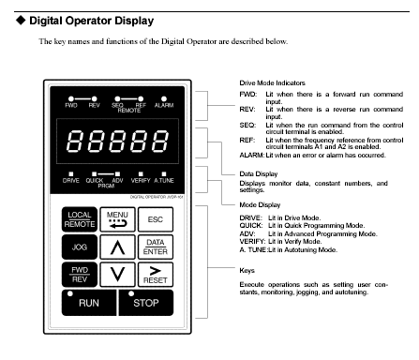
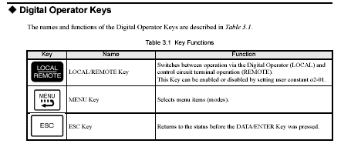
- Acceleration Time: Determines the time it will take the drive to ramp from 0 Hz to maximum frequency.
- Deceleration Time: Determines the time it will take the drive to ramp from maximum frequency to 0 Hz.
- Stop Select: This parameter selects the stopping mode when the drive receives a valid stop command.
- PWM Frequency: This parameter sets the carrier frequency for the sine coded PWM output waveform.
- Current limit: This parameter sets the maximum drive output current that is allowed before limit occurs.
- Overload mode: This parameter selects the derating factor for the I²T electronic overload function.
- Overload amperes: This parameter should be set to motor nameplate FLA for 1.15 SF motors & .9 x nameplate FLA for 1.0 SF motors.
OVERLOAD PATTERNS:
Trip Curves:
Motor name plate parameters:
- Motor NP Hertz
- Motor NP RPM
- Motor NP Ampere
- Motor NP RPM
- Motor NP Volts
The value of these parameters should be set according to the corresponding values given on motor name plate.
For control and tuning the parameters as per application
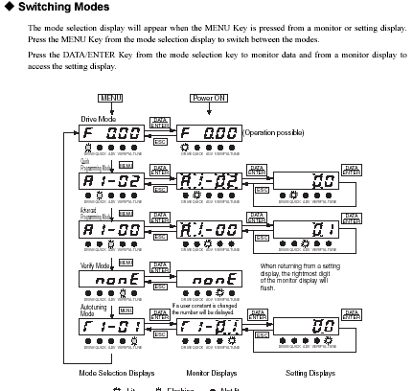
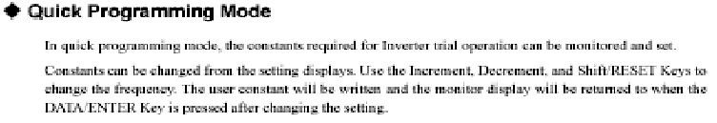
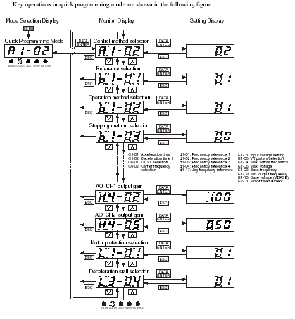
We have to adjust some default/factory setting according to our application
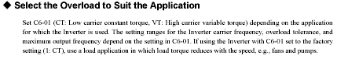
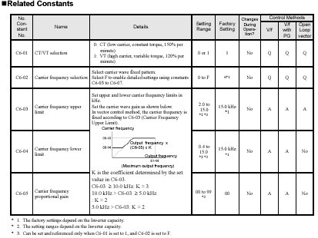

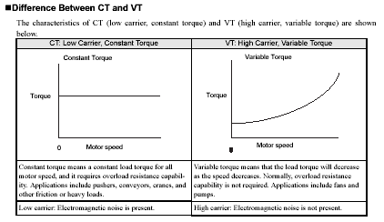
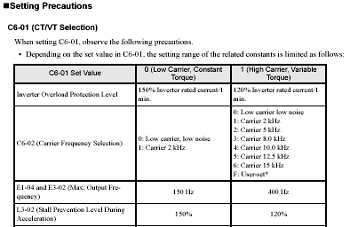

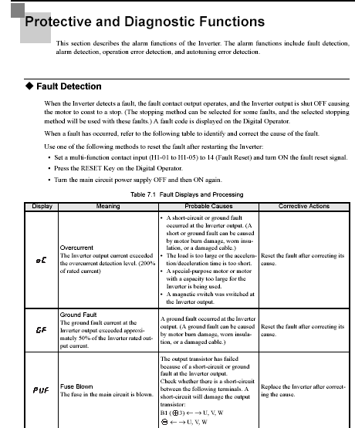

STOVES

CHAPTER 7
RESULTS ANALYSIS

- Studied the working of skip hoist and dc motor control by digital DC drive.
- Studied the working of tilting chute and the ac motor control by digital AC drive.
- Simulation of DC motor control by digital DC drive using PI controller.
Motor Speed and armature current (with PI)
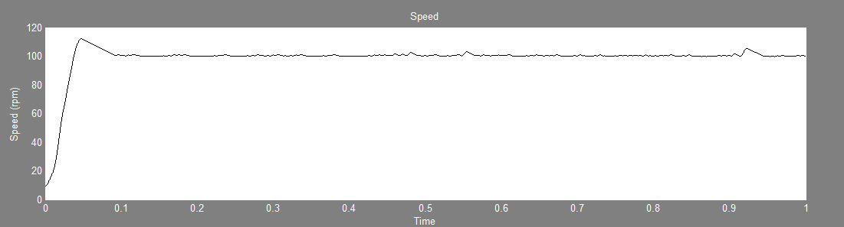
Motor Speed
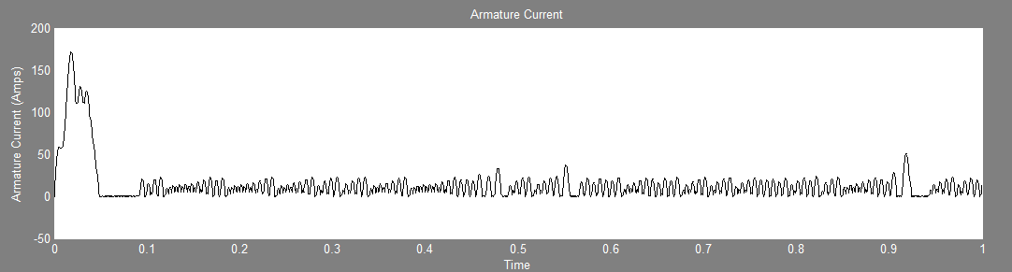Armature Current
Motor torque

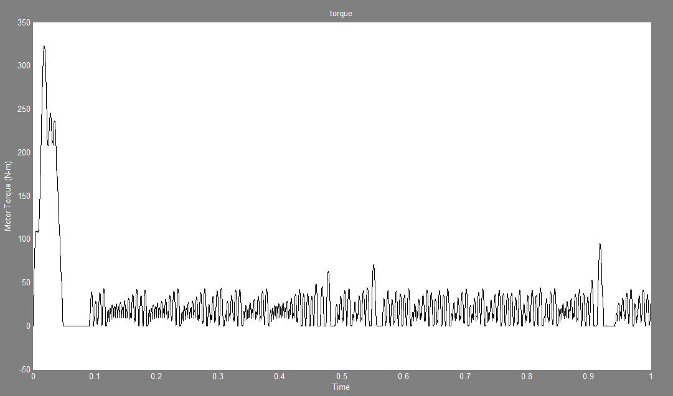

Motor Speed & Armature Current (with PID)
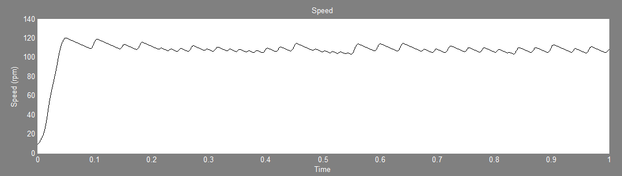

Speed

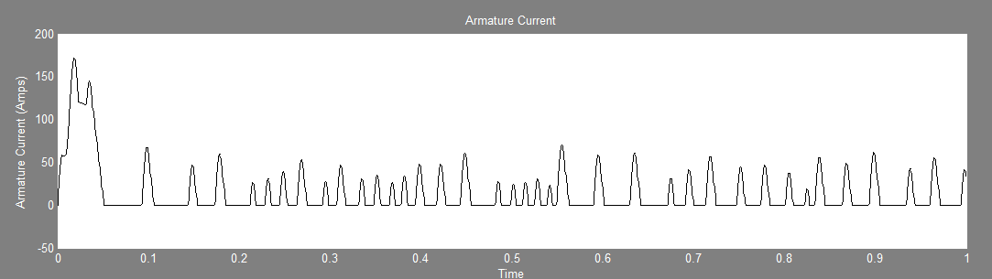
Armature Current
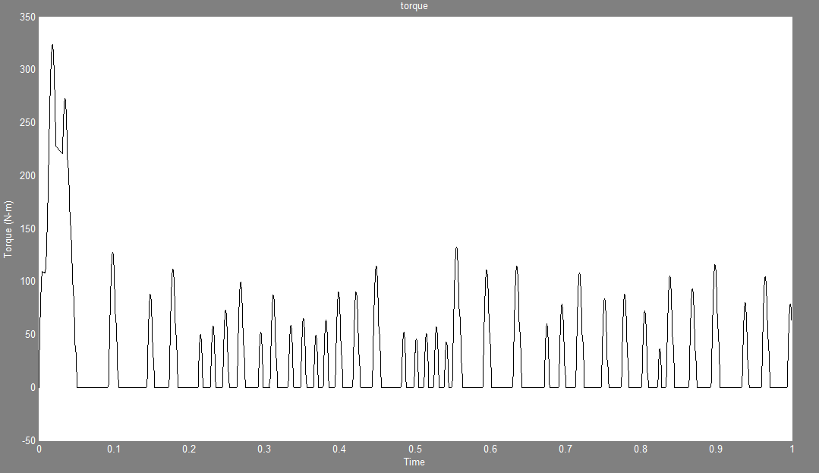

CHAPTER 8
CONCLUSIONS
The working of induction motor with VVVF drives studied and analysis was done on its application in different equipment. The use of VVVF drives is an essential feature of today’s technology to prevent equipment failure and to have efficient control over the process. Another feature that make the VVVF drives more useful is the energy saving and cost reduction. The latest Through these studies, it has been concluded that these parts are very important for the plant as it directly relates with the production.

TECHNICAL REFERENCES
Journal / Conference Papers
- Ai Xiong and Yongkun Fan, “Application of a PID Controller using MRAC Techniques for Control of the DC Electromotor Drive“ IEEE Trans. International Conference on Mechatronics and Automation, August 5 - 8, 2007, Harbin, China
- Enjeti, P.N. Ziogas, P.D. ; Lindsay, J.F. and Rashid, M.H., “Application A new PWM speed control system for high-performance AC motor drives “ Industrial Electronics, IEEE Transactions on (Volume:37 , Issue: 2 ), Apr 1990
- Dennis p. Connors, and Dennis a. Jarc, “Application considerations for AC drives”, IEEE Transactions on Industry Applications, Vol. IA-19, no. 3, pp. 455-460, May/June 1983.

Reference / Hand Books
- Bimal K Bose, “Modern Power Electronics and AC Drives”, Pearson Education Asia 2002.
- R.Krishnan, “Electric Motor Drives, Modeling, Analysis and Control” , Prentice Hall of India, 2002
- Gopal K Dubey, “Power Semiconductor controlled Drives”, Prentice Hall Inc., New Yersy, 1989.
- K. Ogatta, “Modern Control Engineering”, PHI, 2002.

Web
- http://www.parker.com/portal/site/PARKER/menuitem.de7b26ee6a659c147cf26710237ad1ca/?vgnextoid=fcc9b5bbec622110VgnVCM10000032a71dacRCRD&vgnextfmt=EN&vgnextcatid=2688249&vgnextcat=DC590%2B+INTEGRATOR+SYSTEMS+DRIVE
- http://www.yaskawa.com/site/dmdrive.nsf/link2/MNEN-5JLRPN/$file/toe-s616-55_1d_11_0.pdf
- http://en.wikipedia.org/wiki/Brushed_DC_electric_motor

